# VISVESVARAYA TECHNOLOGICAL UNIVERSITY

## JNANASANGAMA, BELAGAVI-590018

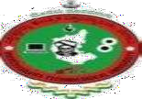

**Seminar Report**

#### on

**“LI-FI TECHNOLOGY”**

**Submitted in Partial fulfillment of the Requirements for the VIII Semester of the Degree of**

**Bachelor of Engineering in**

**Computer Science and Engineering**

#### Submitted by JAILEKHA C USN:-1CR16CS059 MAY - 2020



##### DEPARTMENT OF COMPUTER SCIENCE& ENGINEERING CMR INSTITUTE OF TECHNOLOGY

#132, AECS LAYOUT, IT PARK ROAD, KUNDALAHALLI, BANGALORE-560037

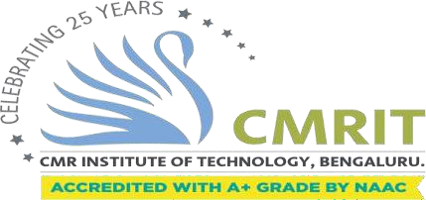

**DEPT. OF COMPUTER SCIENCE & ENGINEERING**

***Certificate***

This is to certify that **Jailekha C(1CR16CS059),** student of CMR Institute of Technology have seminar in partial fulfillment for the award of **Bachelor of Engineering** in **Computer Science and Engineering** of the Visvesvaraya Technological University, Belgaum during the year **2019-2020**. It is certified that all corrections/suggestions indicated for Internal Assessment have been incorporated in the report. This Seminar report has been approved as it satisfies the academic requirements in respect of seminar presentation work prescribed for the said degree.

Place: Bangalore Date:

#### ------------------------

##### Signature of HOD

**Mrs. S. Aarthi,**

**Assistant Professor, Department of CSE** CMRIT, Bengaluru

**ABSTRACT**

Whether you’re using wireless internet in a coffee shop, stealing it from the guy next door, or competing for bandwidth at a conference, you’ve probably gotten frustrated at the slow speeds you face when more than one device is tapped into the network.

As more and more people and their many devices access wireless internet, clogged airwaves are going to make it increasingly difficult to latch onto a reliable signal. But radio waves are just one part of the spectrum that can carry our data.

What if we could use other waves to surf the internet? Taking the fiber out of fiber optics by sending data through an LED light bulb that varies in intensity faster than the human eye can follow. It’s the same idea behind infrared remote controls, but far more powerful. Haas says his invention, which he calls D-Light, can produce data rates faster than 10 megabits per second, which is speedier than your average broadband connection.

# Table of Contents

|  |  |  |  |  |  |
| --- | --- | --- | --- | --- | --- |
| **S. NO.** |  |  |  | **TITLE** | **PAGE NO.** |
| 1 |  |  |  | Introduction | 06 |
| 2 |  |  |  | Literature Review | 07 |
| 3 |  |  |  | Proposed Methodology | 11 |
| 4. |  |  |  | Results and Discussion | 14 |
| 5. |  |  |  | Critical Review | 15 |
| 6. |  |  |  | Conclusion | 17 |
| 7. |  |  |  | References | 18 |

**LIST OF FIGURES**

**S.No TITLE PAGE NO.**

Figure 2.1 Wi-Fi Signal 07

Figure 2.2 Wi-Fi Radio Waves 08

Figure 2.3 Energy Vs Wavelength Graph 09

Figure 2.3 Li-Fi Technology 10

Figure 3.1 Binary Code Transmission 11

Figure 3.2 Working Of Li-Fi 11

Figure 3.3 Architecture Of Li-Fi 12

## Chapter 1

**INTRODUCTION**

Li-Fi is a VLC, visible light communication, technology developed by a team of scientists including Dr Gordon Povey, Prof. Harald Haas and Dr Mostafa Afgani at the University of Edinburgh. The term Li-Fi was coined by Prof. Haas when he amazed people by streaming high- definition video from a standard LED lamp, at TED Global in July 2011. Li-Fi is now part of the Visible Light Communications (VLC) PAN IEEE 802.15.7 standard. “Li-Fi is typically implemented using white LED light bulbs. These devices are normally used for illumination by applying a constant current through the LED. However, by fast and subtle variations of the current, the optical output can be made to vary at extremely high speeds. Unseen by the human eye, this variation is used to carry high-speed data,” says Dr Povey, , Product Manager of the University of Edinburgh's Li-Fi Program ‘D-Light Project’.

As more and more people and their many devices access wireless internet, clogged airwaves are going to make it increasingly difficult to latch onto a reliable signal. But radio waves are just one part of the spectrum that can carry our data. What if we could use other waves to surf the internet?

One German physicist,DR. Harald Haas, has come up with a solution he calls “Data Through Illumination”—taking the fiber out of fiber optics by sending data through an LED light bulb that varies in intensity faster than the human eye can follow. It’s the same idea behind infrared remote controls, but far more powerful. Haas says his invention, which he calls D-Light, can produce data rates faster than 10 megabits per second, which is speedier than your average broadband connection. He envisions a future where data for laptops, smartphones, and tablets is transmitted through the light in a room. And security would be a snap—if you can’t see the light, you can’t access the data.

# Chapter 2

**Literature Survey**

Let’s Talk Little bit about Wi-Fi, We all know that Wi-Fi transform the digital communication. Without this technology our mobile way of life would somewhat different. Wi-Fi currently uses 60% of all internet traffic.

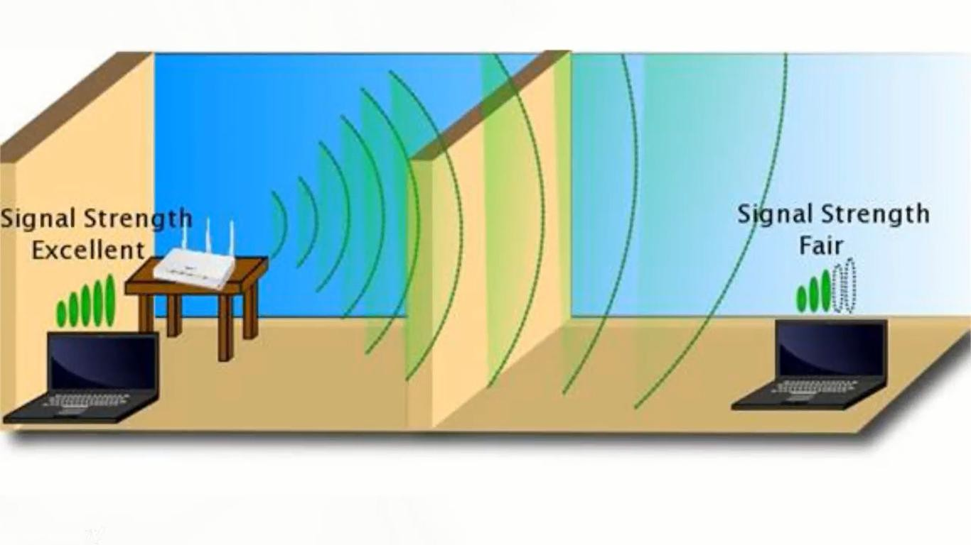

Fig.2.1

With all that being said, Wi-Fi still have some issues like it get sketchy when signal get varied and it’s not totally secure because the signal can travel through walls and be easily picked up by someone else.

The reason for all of this is that Wi-Fi uses radio waves to transmit the data.

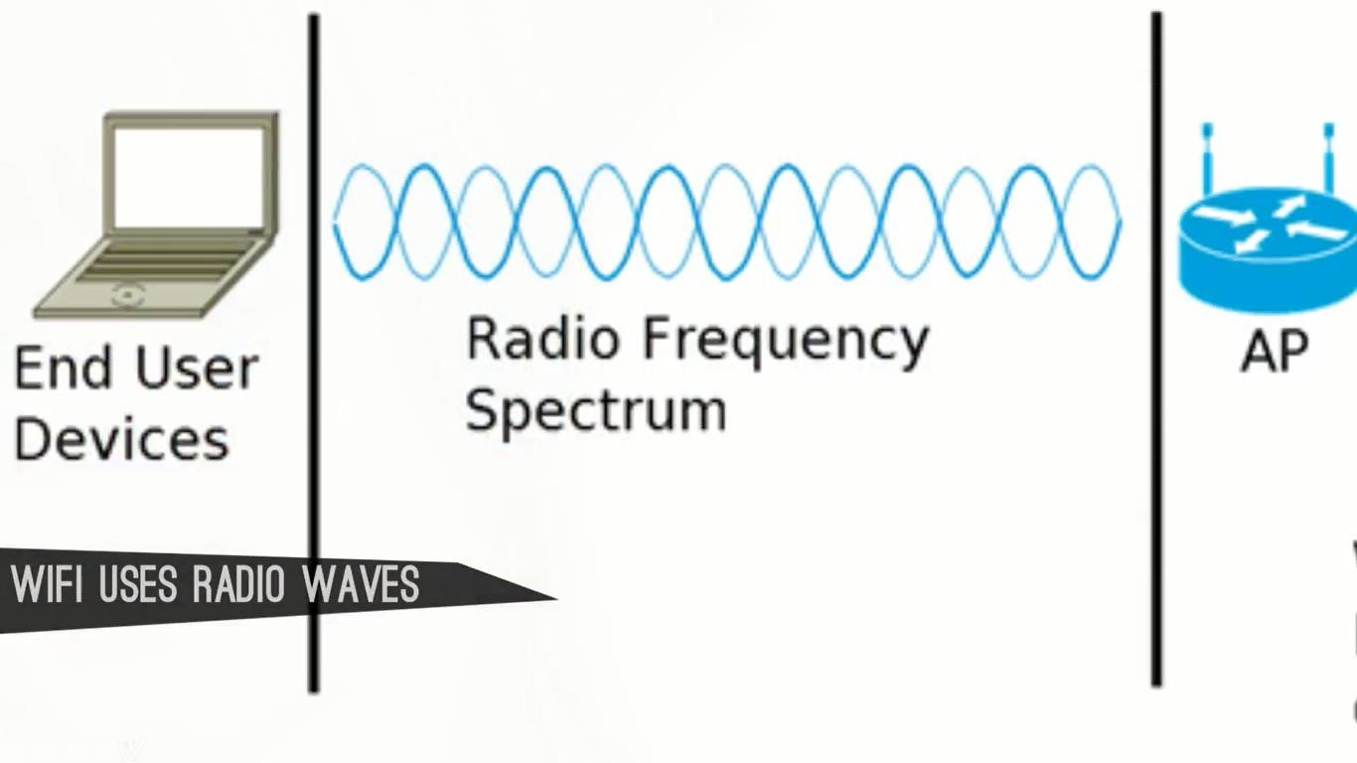

Fig.2.2

So how do improve this technology and solve these problems. We must use something which is cheap, secure and more robust for transfer the data.

The answer for that is “Light”



Light is just perfect, because it is in the electromagnetic spectrum and radio waves are also in the electromagnetic spectrum but the visible reason has the high frequency.

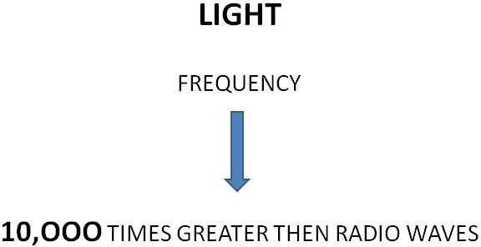

All this means is that light has the capacity to transfer the data at much higher speed and a very vast data in less time then the radio waves.

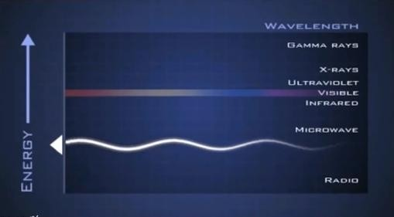

Fig.2.3

So the concept in which Light is just as a medium for transferring the internet data is called Li- Fi(Light-fidelity).

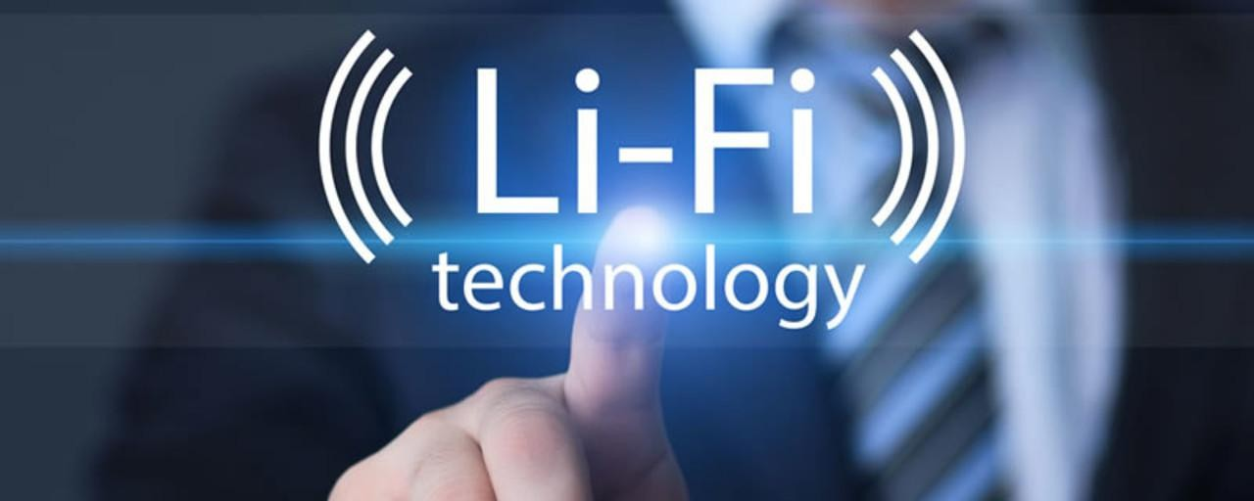

Fig.2.4. LI-FI TECHNOLOGY

### Chapter 3

**Proposed Methodology**

So we all know about the remote control at our home have a Infra-red sersor. Basically Switching on the light, Switching off the light causes the simple and single stream of data which can transmit with a speed of 20,000 bits per second.

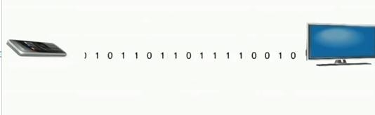

Fig.3.1

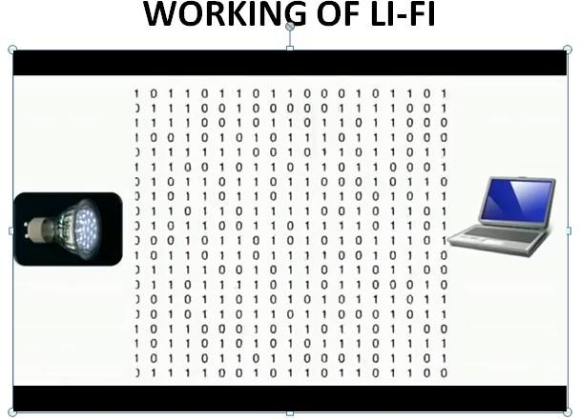But in case of Li-Fi we have thousands of data streams which travels at a very high speed in parallel.

Fig.3.2

### Archite*c*ture of Li-Fi

Li-Fi is typically implemented using white LED light bulbs at the downlink transmitter. These devices are normally used for illumination only by applying a constant current. However, by fast and subtle variations of the current, the optical output can be made to vary at extremely high speeds.

This very property of optical current is used in Li-Fi setup. The operational procedure is very simple-, if the LED is on, you transmit a digital 1, if it’s off you transmit a 0. The LEDs can be switched on and off very quickly, which gives nice opportunities for transmitting data. Hence all that is required is some LEDs and a controller that code data into those LEDs. All one has to do is to vary the rate at which the LED’s flicker depending upon the data we want to encode.

Further enhancements can be made in this method, like using an array of LEDs for parallel data transmission, or using mixtures of red, green and blue LEDs to alter the light’s frequency with each frequency encoding a different data channel. Such advancements promise a theoretical speed of 10 Gbps – meaning one can download a full high-definition film in just 30 seconds.

##### LIFI NETWORK PERFORMANCE ANALYSIS

In this section, the performance of Li-Fi networks is considered and evaluated. This is extended to hybrid Li-Fi/Wi-Fi networks. Finally, we report results from a real-world hybrid Li-Fi/Wi-Fi

network deployed in a school. With appropriate cooperation between the two networks, the overall system performance can be significantly improved as there is no mutual interference.

So again it is that light(comes from the LED light to receiver that transmit the data, also the light from the surrounding also comes to the receiver but receiver just reject the constant light because the receiver is interested in the subtle changes.

In Future these receiver will get integrated into the mobile devices and to all the internet of things, so that they can also works on Li-Fi.

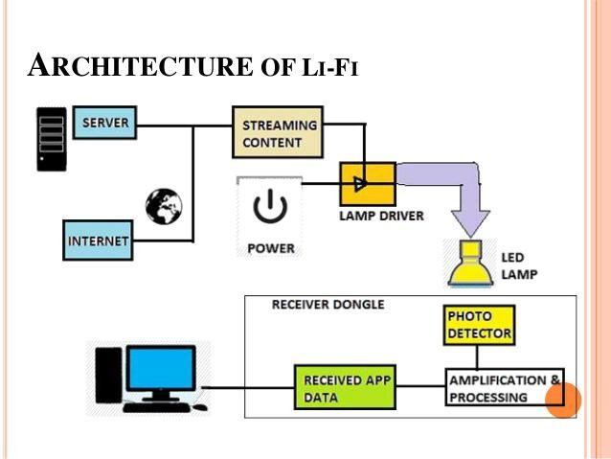

Fig.3.3

##### WHAT IF LIGHT IS TURNED OFF

You might we wondering if the light has to be turned on whole the time for transmission of data so how can we use this technology in the night time.

The Answer For this question is that we can dim the light down upto a level so human eye can’t detect it but the receiver can read it.

##### MAIN ATTRACTION IN LI-FI

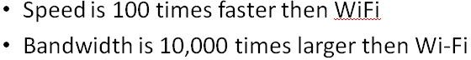

**Chapter 4**

**RESULTS AND DISCUSSION**

Li-Fi is typically implemented using white LED light bulbs at the downlink transmitter. These devices are normally used for illumination only by applying a constant current. However, by fast and subtle variations of the current, the optical output can be made to vary at extremely high speeds.

This very property of optical current is used in Li-Fi setup. The operational procedure is very simple-, if the LED is on, you transmit a digital 1, if it’s off you transmit a 0. The LEDs can be switched on and off very quickly, which gives nice opportunities for transmitting data. Hence all that is required is some LEDs and a controller that code data into those LEDs. All one has to do is to vary the rate at which the LED’s flicker depending upon the data we want to encode.

Further enhancements can be made in this method, like using an array of LEDs for parallel data transmission, or using mixtures of red, green and blue LEDs to alter the light’s frequency with each frequency encoding a different data channel. Such advancements promise a theoretical speed of 10 GBPS – meaning one can download a full high-definition film in just 30 seconds.

##### RECENT RESEARCH AT OXFORD UNIVERSITY

Currently a researcher at Oxford University claims that li-fi can speed up to 254GBps. With that speed you can download 18 high definition movies in one second.

Of course, whether or not server is able to deliver that much of speed but currently servers cannot give us that much of speed and there is a condition called speed bottleneck in the servers.

### Chapter 5

**CRITICAL REVIEW**

The applications for Li-Fi are limitless. Anywhere there is an LED light there can be data. Li-Fi is a platform technology that will extend the capabilities of wireless communications to places beyond even our current conception.

Today there are real life applications and benefits for implementing Li-Fi. Li-Fi can enable secure wireless communications, connectivity in RF hostile environments such as petrochemical plants and hospitals. Currently a researcher at Oxford University claims that li-fi can speed up to 254GBps. With that speed you can download 18 high definition movies in one second.

Of course, whether or not server is able to deliver that much of speed but currently servers cannot give us that much of speed and there is a condition called speed bottleneck in the servers.

Li-Fi also provides high speed, dense and reliable networks for enterprise environments and

a pathway to enable smart buildings, transport, cities, and nations.

The main motive about the li-fi technology is to enable secure wireless communications,

connectivity in RF hostile environments such as petrochemical plants and hospitals.

Li-Fi also provides high speed, dense and reliable networks for enterprise environments and

a pathway to enable smart buildings, transport, cities, and nations.

As mentioned above li-fi proves to be the best in coming years, but still everyone has one

doubt CAN OR CANNOT IT BE HACKED?

The explanation for the above is: since light cannot pass through walls, it is thought that Li-

Fi signals cannot be easily hacked. But, Li-Fi has certain operational limitations. The light

source will have to be kept on to use the network. The Li- Fi range is also smaller than the

Wi-Fi range.

One of the biggest challenge of Li-Fi technology is it requires the line of sight. When setup outdoors, the apparatus would need to deal with ever changing conditions.

Indoors, one would not be able to shift the receiving device. A major challenge facing Li-Fi is how the receiving device will transmit back to transmitter.

Though it has many advantages, one of the smallest disadvantage is the light can be blocked by somebody simply walking in front of LED source.

A side effect of Li-Fi is that your power cord immediately becomes your data stream. If you have power, you have internet.

As light is everywhere and free to use, there is a great scope for the use and evolution of Li-Fi technology. If this technology matures, each Li-Fi Bulb can be used to transmit data. As the Li-Fi technology becomes popular, it will lead to a cleaner, greener, economical, and safer communication system.

### CHAPTER 6

**CONCLUSION**

The conclusion is that, we can fit these cheap light powered internet or LI-FI everywhere and the dream of internet of things will come into reality, a situation where all the electronic devices will communicate with each other. Your phone will communicate with your fridge and the sensors at bridge will warns if there any damage.

Currently a researcher at Oxford University claims that li-fi can speed up to 254GBps. With that speed you can download 18 high definition movies in one second.

Of course, whether or not server is able to deliver that much of speed but currently servers cannot give us that much of speed and there is a condition called speed bottleneck in the servers.

If Li-Fi become widely available then believe me this technology turns this world into a place where internet or transfer of information is not an obstacle.

Lastly, I would like to say that Li-Fi is not a disruptive technology that would displace Wi-Fi.

Li-Fi is complementary to Wi-Fi, in the same way as Wi-Fi is complementary to cellular network.

It can work in conjunction with existing Wi-Fi networks to provide faster and more secure internet connections.

### CHAPTER 7

### REFERENCES

##### Websites:

1. <https://en.wikipedia.org/wiki/Wi-Fi>
2. [https://www.smh.com.au/technology/move-aside-wifi-theres-a-new-superfast-](https://www.smh.com.au/technology/move-aside-wifi-theres-a-new-superfast-wireless-internet-coming-called-lifi-20151125-gl7j79.html) wireless-internet-coming-called-lifi-20151125-gl7j79.html
3. [https://purelifi.com/technology/#white-paper](https://purelifi.com/technology/)
4. [https://www.techworld.com/data/what-is-li-fi-everything-you-need-](https://www.techworld.com/data/what-is-li-fi-everything-you-need-know-3632764/) know-3632764/

##### Journals:

1. [Access Point Selection Scheme for Li-Fi Cellular Networks using Angle Diversity Receivers](https://ieeexplore.ieee.org/document/8885720/) [Zhihong Zeng](https://ieeexplore.ieee.org/author/37086800783) ; [Mohammad Dehghani Soltani](https://ieeexplore.ieee.org/author/37086064835) ; [Xiping Wu](https://ieeexplore.ieee.org/author/38490662900) ; [Harald Haas](https://ieeexplore.ieee.org/author/37269894900)
2. [Introduction to indoor networking concepts and challenges in Li-Fi](https://ieeexplore.ieee.org/document/8932632/)

Harald Haas ; Liang Yin ; Cheng Chen ; Stefan Videv ; Damian Parol ; Enrique Poves ; Hamada

1. [Load Balancing for Hybrid Li-Fi and Wi-Fi Networks: To Tackle User Mobility and Light-Path](https://ieeexplore.ieee.org/document/8943127/) Blockage

[Xiping Wu](https://ieeexplore.ieee.org/author/38490662900) ; [Harald Haas](https://ieeexplore.ieee.org/author/37269894900)